|  |  |
| --- | --- |
| TEAM ID | PNT2022TMID39941 |
| TOPIC | SMART SOLUTION FOR RAILWAYS |
| DATE | 19-OCTOBER-2022 |

CREATING WEB APP USING NODE RED:

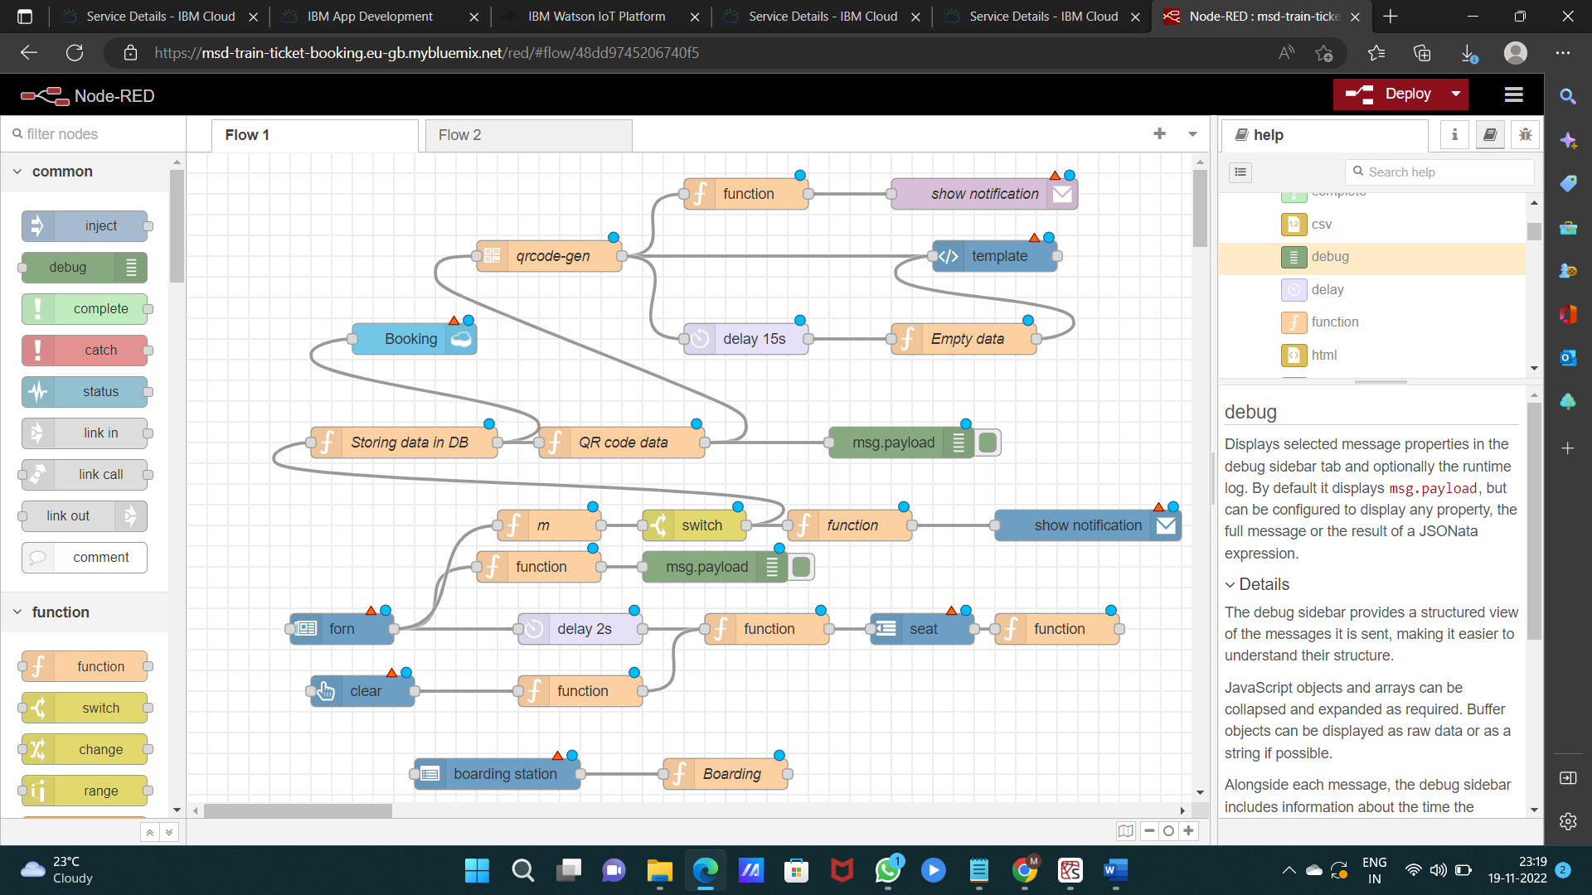

NODE RED OUTPUT:

